# ProjectDesignPhase-II

**DataFlowDiagram&UserStories**

|  |  |
| --- | --- |
| Date | 09May2023 |
| TeamID | NM2023TMID19127 |
| ProjectName | Automated weather classification using transfer learning |

## DataFlowDiagrams:

A Data Flow Diagram (DFD) is a traditional visual representation of the information flows within a system. A neat and clear DFD can depict the rightamount of the system requirement graphically. It shows how data enters and leaves the system, what changes the information, and where data isstored.

## Example:[(Simplified)](https://developer.ibm.com/patterns/visualize-unstructured-text/)

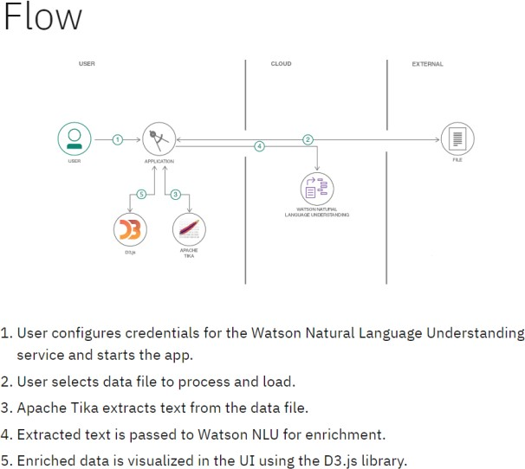

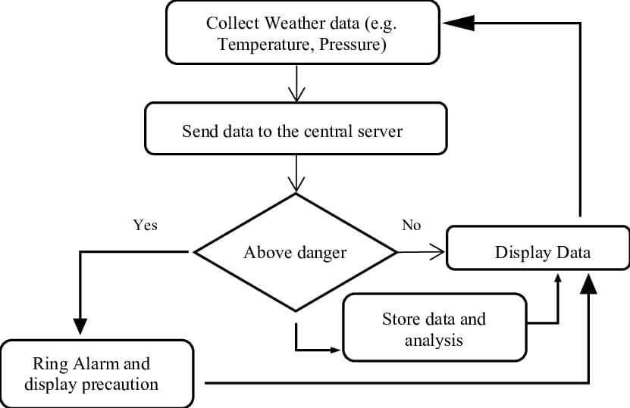

**DFD Diagram for automated weather classification using transfer learning**

**UserStories**

Usethebelowtemplatetolistalltheuserstoriesfortheproduct.

|  |  |  |  |  |  |  |
| --- | --- | --- | --- | --- | --- | --- |
| **UserType** | **FunctionalRequirement**  **(Epic)** | **UserStoryNumber** | **UserStory/Task** | **Acceptancecriteria** | **Priority** | **TeamMember** |
| Customer(Mobileuser) | Registration | USN-1 | Asauser,Icanregisterforthe applicationby  enteringmyemail,password,andconfirmingmypassword. | Icanaccessmyaccount/dashboard | High | Logesj |
|  |  | USN-2 | Asauser, IwillreceiveconfirmationemailonceI haveregisteredfortheapplication | Icanreceiveconfirmationemail&clickconfirm | High | Akash |
|  |  | USN-3 | Asauser,IcanregisterfortheapplicationthroughFacebook | Icanregister&accessthedashboardwithFacebook  Login | Low | Madhan |
|  |  | USN-4 | Asauser,IcanregisterfortheapplicationthroughGmail |  | Medium | Revathy |
|  | Login | USN-5 | Asauser,Icanlog intothe applicationbyentering email& password |  | High |  |
|  | Dashboard |  |  |  |  |  |
| Customer (Webuser) |  |  |  |  |  |  |
| Customer CareExecutive |  |  |  |  |  |  |
| Administrator | Manage theproduct | USN-6 | As a developer, I want to build a user-friendlyweb application that allows users to uploadimagesoftheirgarbageandreceivefeedbackonhowtosortitproperly. | We can detect weather classification using image. | High | Akash |
| Homeowner | Signin | USN-7 | As a homeowner, I want to be able to sort mygarbagemoreeffectively. | Allows for data to be gathered to build up a more detailed picture of a nation's climate, and trends within it. | Low | Logesh |
| MunicipalRecycling | Login | USN-8 | As a municipal recycling center employee, Iwanttobeabletoquicklyandaccuratelysort  incomingwastematerialsbytype. | Enables you to properly plan your farm operations, such as planting, irrigation, fertilizer application, pruning/weeding, harvesting or livestock mating | High | Madhan |

|  |  |  |  |  |  |  |
| --- | --- | --- | --- | --- | --- | --- |
| **UserType** | **Functional**  **Requirement(Epic)** | **UserStoryNumber** | **UserStory/Task** | **Acceptancecriteria** | **Priority** | **TeamMember** |
|  |  |  |  |  |  |  |
| WasteManagement | Dashboard | USN-8 | As a waste management professional, I wanttobe abletoautomaticallysortdifferenttypesof wasteusingcomputervision. | Accurate weather forecasting is critical in the agriculture industry. | High | Revathy |